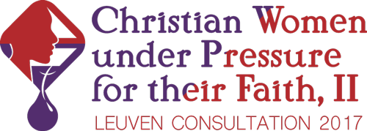

15th February, 2017

We would like to extend to you a very warm invitation to the second Working Consultation on **Christian Women under Pressure for their Faith** at the Evangelische Theologische Faculteit in Leuven, Belgium.

Arrival Wednesday 31st May 2017, meetings from 8:00 Thursday 1st June to 16:00 Saturday 3rd June.

This year’s Consultation seeks to build upon the foundation of the Marcham Conference in March 2016 on Women and Persecution. We again hope to draw practitioners and academics together to share learning through both practical reflection and critical thinking within a foundation of prayer. We will examine practices that support persecuted women and look in more depth at the unique and painful issues that women face in hostile and abusive environments where they suffer in identifying with Christ.

A Consultation would be incomplete without the first-person voice of our persecuted sisters and so they will be an integral part of the program.

In the true spirit of a working consultation, your active contributions to the Table Talk time scheduled after every presentation will be a key element in the collaborative process of building understanding of issues.

As well as plenary presentations and table talks, all participants of the consultation will choose to collaborate in one of the following groups in order to fulfil the relevant outcomes:

* Best Practice working groups: creating Guidelines on Best Practices for those serving and living through persecution with or as Christian women.
* Letter to the Global Church working groups: amending the 2016 Marcham letter and developing communication steps in order to maximize adherence and impact.
* Scholarly Track: A separate call for papers will be issued. Up to 8 academic papers related to the topic of the consultation will be considered. These might be published in post-conference outlets, subject to peer review.

Time will be allocated in the program to work on the above outcomes over four sessions.

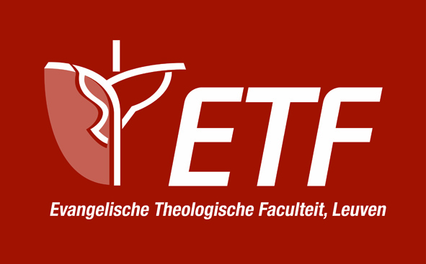The consultation can hold a limited number of participants, so please complete the application promptly to guarantee your place. All registrations should be received no later than 24th March (please see below for further information.)

With God’s richest blessings,

Emma Dipper, Steering Committee Chair

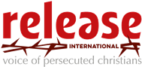****Christof Sauer, christof.sauer@etf.edu

Emma Dipper, edipper@releaseinternational.org

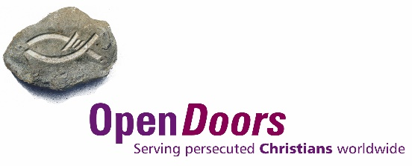Helene Fisher, helenef@od.org

Elizabeth Miller, elizabethm@od.org

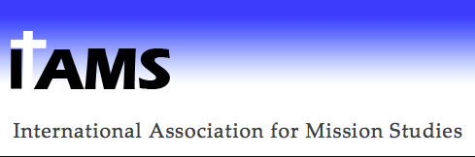



**Programme**

The programme is divided into 3 subjects over 3 days:

* Exploring the Issues
* Engaging the Challenges
* Endeavouring on Healthy Responses

We will cover the following subjects through brief presentations and segmented table talks:

* A Biblical and Theological Framework for Christian Women under Pressure for their Faith
* Issues for Women under Pressure for their Faith (in different and diverse geographic regions)
* Exploring Freedom of Religion or Belief (FORB) in the context of Christian women
* Power and Authority: how does ideology make a difference?
* Poverty: tool or outcome of persecution?
* Legal Status: inconvenience or vulnerability for women?
* Syncretism – societal values and persecution dynamics
* Rape and Seduction – strategy or by-product?
* Healing the past – addressing a change in mindset and identity
* Training for Transformation – Understanding Biblical Masculinity
* Building Resilience and Building the Church under Pressure

NB: This is not a complete programme.

**Funding, Collaboration and Endorsement**

This working consultation celebrates collaboration and is being organised in partnership with the International Institute for Religious Freedom (IIRF). Release International, Open Doors International and the Evangelical Alliance of Denmark are generously supporting the vision of this conference by practical support and finance.

The scholarly track is organized conjointly by the International Institute for Religious Freedom, the Initiative for the Study of Freedom of Religion or Belief (ETF) and the Study Group on Religious Freedom, Persecution and Mission of the International Association for Mission Studies.

The Religious Liberty Partnership fully endorses this consultation. Having supported the last consultation in 2016 we see the immense need and value in joining together to understand and respond appropriately to the needs of Christian women living under pressure for their faith.

Please do let us know if there are any bodies of funding that would be interested in supporting this consultation as we break new ground in knowledge and practice.

**Consultation Venue and Fees**:

Evangelische Theologische Faculteit Leuven Fees, not including accommodations: £160  
Sint-Jansbergsesteenweg 95-97 **(Please see Application Form for more details)**3001 Leuven  
Belgium

+32 16 20 08 95 Travel Directions can be found at:

[www.etf.edu](http://www.etf.edu) <http://www.etf.edu/en/etf/contact/travel-directions/>

**Accommodation**:

All participants are responsible for booking their own accommodation directly with hotels.

We have blocked a limited number of rooms at the local IBIS Budget Hotel in Leuven from 31st May to 4th June (4 nights), but most attendees can travel home the 3rd June, reducing the stay to 3 nights if you prefer. **(Please see Application Form for more details)**